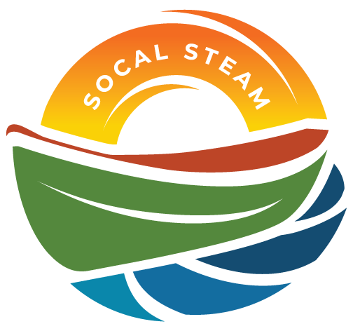
SoCal STEAM Challenge
Technical Workshop with SoCal STEAM Teachers
Date | Time 2/11/2026 4:30 PM Location Microsoft Teams
Join the meeting now
Meeting ID: 261 323 851 299 23
Passcode: Np25qa7C

Agenda Items
- Welcome and Introductions
  - Schools
  - Committee Members

- 2026 Event Discussion
  - Event Weekend – May 1-3, 2026
  - Participation and Camping
  - Timeline of Events
  - Meals
- Rules
  - Sponsorships
  - Inspections and Qualifying
  - Races
- Reports and Presentations
  - PSA Topic
    - Outline Due February 25th
  - Technical Reports
    - Electrical and Solar Array
    - Drive Train and Steering
- Additional Items/Discussion

- Race/Presentation Order
- Adjourn

