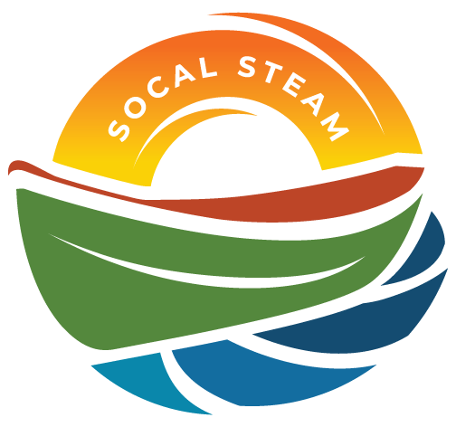
SoCal STEAM Challenge
Meeting with SoCal STEAM Committee
Date | Time 9/25/2025 3:00 PM Location Microsoft Teams
Join the meeting now
Meeting ID: 215 864 501 959 4
Passcode: Lo3eb2rX

Agenda Items
- Welcome and Introductions
  - San Bernardino Municipal Water Department - Devin Arciniega, Darian Brown, Victoria Rodriguez
  - Yucaipa Valley Water District - Micah Knox, Jennifer Ares
  - East Valley Water District – Janett Robeldo, Cecilia Contreras
  - West Valley Water District – Amber Cuevas
  - City of Redlands – Samatha Bortoli
  - City of Colton – Cecilia Griego
  - San Bernardino Valley Municipal Water District
  - City of Ontario

- Approval of Committee Meeting Minutes from May 14, 2025 – Approval of minutes moved to next meeting.

- Roles / Assignments – Committee roles were discussed and will be agendized for the next meeting for a vote. Chair Robledo mentioned a need for a better system of maintenance for the website and more active social media platform sharing. The hope for this action is to better engage potential sponsors and schools. City of SB Water agreed to take on social media for the year, and discussions were held regarding how best to use the platforms to engage students and highlight the event.
- Update Banking Authorized Signers – This item will be moved to the next meeting to be agendized and voted on by the committee. Next steps would be to have board members make a trip to the bank to file name change and all authorized signers.

- Task List – Task list was reviewed and member agencies/individuals assigned roles for the event. Teacher kickoff meeting was discussed for possible dates, committee settled on Oct. 16. Discussion was had to change the boat build to a meeting and pick up day due to low attendance during previous years. Chair Robledo will bring this change up during the teacher’s kick off meeting. Questions were brought up during the assigning of the boat build regarding particular cutting requirement for the wood, YVWD will follow up with Chair Robledo. Redlands may take on catering for Sunday— awaiting next meeting. Committee discussed which food options would be good for Sunday Lunch. Committee will ask the teachers what date they prefer for the boat build: November 22 or December 6.
- Yucaipa Regional Park – Deposit placed with YRP, event will be May 1-3.
- Schedule – Dates for event timeline discussed.

- 501c3
  - Taxes – Taxes filed by Treasurer Contreras
  - Statement of Information
    - When is it due. Is there action needed. – Committee member Hartley to check in on this with Wrobel.
  - Name change/ Status (Wroble) - Committee member Hartley to check in on this with Wrobel.

- Schools – Discussion was had about possibly bringing in other schools. Committee member Arciniega mentioned she may not have a school this year.

- Public Service Announcement (PSA) – Chair Robledo began discussions on what the new PSA topic would be. The topic that was chosen was to provide schools with a scenario, making them water conservation specialists and asking them to create a program that would help save water. Chair Robledo will draft a prompt and bring it to the next meeting to share.
- Budget - $19,387 has been rolled over from previous years. Several fees have been paid for this year, including Drop Box fees, Park application and tax filings fees. Current $19,227. Committee member Griego submitted a grant through EPromo. If awarded, SoCal STEAM will be eligible to receive up to $50 in promo items. At this date, committee member Griego has not heard back. Discussions were held about increasing sponsorship amount for the event. Treasurer Contreras mentioned that any sponsorship increase would need to go to a vote during a meeting. She also mentioned that she keeps track of monetary versus in-kind donations.

- Rule Updates – Chair Robledo requested that all committee members review the rules for any changes.
- Sponsorships – Chair Robledo encouraged all committee members to reach out to potential sponsors.
- Next Meeting - A discussion arose about adding in an item for next meeting regarding the change of the sportsmanship award. More discussion to follow at the next meeting. Next meeting will be October 16, 2025 at Yucaipa Valley Water District. Committee meeting will be 4-5 p.m. and the teacher meeting will follow.
- Adjourn

