

Rules of Participation
2026 Event

Janett Robledo, East Valley Water District

Chair

jrobledo@eastvalleywater.gov

Jennifer Ares, Yucaipa Valley Water District

Vice-Chair

jares@yvwd.us

Micah Knox, Yucaipa Valley Water District

Vice-Chair

mknox@yvwd.us

Table of Contents

SoCal STEAM Challenge - Mission

- 2026 SoCal STEAM Challenge Schedule of Events

- Definitions
  - Inspection/Staging Area
  - On Deck Area
  - Launching Site
  - System Voltage
  - Source Voltage
  - Kill Switch with Tether
  - Power Indicator Lamp

- Administration
  - Application of Rules
  - Effective Date of Rules
  - Right to Revise Rules
  - Acceptance of Rules
  - Program Administrator
  - Sponsorship
  - Event Officials
  - Insurance
  - Accidents
  - Parent / Guardian Release and Waiver of Liability
  - Statement of Swimming Ability for Skippers
  - Withdrawals

- Registration and Inspections
  - Registration
    - Point of Contact
    - Faculty and Guests
  - Technical Inspections
    - Safety
    - Swimming Ability
    - Ballast
    - Configurations
    - Modifications
    - Stem
    - Solar Array Output

- Entries
  - Team Member Eligibility
  - Skipper Eligibility

- Venue
  - Site

- Regulations
  - Slalom
  - Solar Endurance
  - Sprint
  - Technical Specifications
    - Length
    - Width
    - Height
    - Depth
    - Cross Sectional Area
    - Weight
  - Materials
  - Power
    - Storage of Solar Radiation
    - Supplemental Batteries (Auxiliary Batteries)
    - System Voltage
    - Source Voltage
  - Visibility
  - Stability
  - Throttle
  - Ballast Carrier
  - Automatic Bilge Pump
  - Covers and Shields
  - Electrical
    - Motors
    - Shock Hazards
    - Battery Type
    - Battery System
    - Battery Switch
    - Main Fuse
    - Other Fuses
  - Radios
  - Skipper Cockpit
    - Harnesses
    - Safety
    - Power Indicator Lamp
  - Fasteners
    - Drive Train
    - Batteries
    - Solar Panels
  - Safety Equipment
    - Life Preservers
    - Buoyancy of Boat
    - Towing
    - Signal Devices
    - Paddle
    - Fire Extinguisher
    - Propeller Warning
    - Safety Plan

- Competition Events
  - Inclement Weather
  - Skipper’s Meetings
  - Start and Finish
  - Course
    - Qualifying
    - Slalom
    - Sprints
    - Endurance
  - Overtaking
    - Overtaking on a Straightaway
    - Overtaking at a Buoy
  - Buoys
  - Leaving the Course
  - Boat Staging

- Scoring
  - Scoring and Results
  - Overall Scoring
    - Technical Inspections
    - Technical Reports
    - Public Service Announcement
    - Slalom
    - Sprint
    - Endurance Event

- Graphics
  - Boat Number Signs
  - Event Logo
  - School Name
  - Sponsor Identification
  - Inappropriate Graphics
- Penalties
  - Deadline Penalties
  - Qualifying Penalties
    - Unprepared for Qualifying
    - Leaving the Course
    - Striking a Buoy
    - Mechanical/Electrical Failure
    - Disturbing Official Battery Markings
    - Obstructive Boating
  - Slalom and Sprint Penalties
    - Leaving the Course
    - Striking a Buoy
    - Mechanical/Electrical Failure
    - Disturbing Official Battery Markings
  - Endurance Penalties
    - Leaving the Course
    - Striking a buoy
    - Mechanical/Electrical Failure
    - Disturbing Official Battery Marking
    - Obstructive Boating
    - Failure to Yield to Right-of-Way
  - Paddling
  - Skipper’s Meetings
  - Conduct

- Prizes and Awards
  - Race Awards
  - Overall Awards
  - Other Awards
  - Award Ceremonies

- Procedures
  - Staging
  - Swimmers
  - Protective Wear
  - Rule Interpretation
  - Boat Removal

- Advertising, Promotion and Publicity

Appendices Appendix A - Parent / Guardian Release and Waiver of Liability Appendix B - Statement of Swimming Ability for Skippers Appendix C – Technical Report Rubric
Appendix D – Public Service Announcement Grading Rubric Appendix E – Grading sheet for Technical Inspections Appendix F – June Hayes Sportsmanship Award
Appendix G- Example: Launch/Retrieval Plan

SoCal STEAM Challenge – Mission
The SoCal STEAM Challenge is dedicated to cultivating a sustainable future by empowering the next generation of sustainability leaders in Southern California. Our mission is to provide students with comprehensive information and resources, igniting their passion for careers in STEAM fields. Through education and advocacy, we aim to instill a deep understanding of the value of Earth’s resources, with a focus on water and energy, and their critical role in sustaining our communities and ecosystems, ensuring that young minds lead the way in sustainable innovation and environmental responsibility.

2025 SoCal STEAM Challenge Schedule of Events

Event | Date
Registration | Friday, May 1 – 8:00 a.m. – 2:00 p.m.
Technical Inspections* | Friday, May 1 – 8:00 a.m. – 1:00 p.m.
Qualifying | Friday, May 1 – 1:00 p.m. – 4:00 p.m.
Sprint | Saturday, May 2 – 8:40 a.m. – 11:20 a.m.
Slalom | Saturday, May 2 – 1:20 p.m. – 4:00 p.m.
PSA Presentations | Saturday, May 2 – 5:40 p.m. – 7:00 p.m.
Endurance | Sunday, May 3 – 8:40 a.m. – 11:10 a.m.
*Detailed technical inspection will not take place before every event, however, all boats will have a quick assessment
before each race.

Race days and times are at the discretion of the SoCal STEAM Committee. Weather conditions may dictate competition days and times. A definitive schedule will be distributed closer to the Event.

Definitions

  - Inspection/Staging Area - Competing team boats will be in this area to prepare for inspections prior to qualifying for event race. Here, the teams may work on their boat and complete any last-minute modifications. Teams are to adhere to the scheduled timeframe for boat inspection. Team boats that have completed inspection and obtained approved clearance for Qualifying Heat from a designated SoCal STEAM inspector will then receive authorization to proceed to On Deck Area.

  - On Deck Area - The On Deck Area is located at the lakefront. Team boats will move from On Deck Area to Launching Site when announced by a SoCal STEAM Committee member.

  - Launching Site – Area which extends 20 ft. from point of entry in all directions. Access to this area is limited to the skipper, officials, and team members needed to launch the boat.

  - System Voltage - Voltage shall be measured with a Volt Ohm Ampere (VOA) meter between the system ground and any point in the electrical system.

  - Source Voltage – The nominal value, e.g. 24 Volt Direct Current (VDC), of the output voltage of the battery pack.

  - Kill Switch with Tether - A device that disengages the power to the motor when the skipper leaves the boat using a commercially available marine specific kill switch and tether that are designed for personal watercraft. The tether must be securely fastened to the life vest of the skipper in the boat and function must be demonstrated in an egress test during Technical Inspection.

  - Power Indicator Lamp- A flashing lamp visible to onlookers indicating that battery power is on.

Administration

  - Application of Rules - The Rules shall apply to the SoCal STEAM Challenge, hereinafter referred to as “SoCal STEAM” or “Event”.

  - Effective Date of Rules - The Rules become effective immediately.

  - Right to Revise Rules – The SoCal STEAM Committee reserves the right to revise the Rules at any time by providing the participants notification of revisions in the form of Bulletins, revised editions of the Rules, or announcements at the Event.

  - Acceptance of Rules - All persons or groups selected to participate in the Event are expected to know and accept the Rules. Participation in the Event shall constitute acceptance of the Rules.

  - Program Administrator - The program is administered and coordinated by the SoCal STEAM Committee. All correspondence and inquiries for/about the program should be addressed to:

Janett Robledo, Chair
jrobledo@eastvalleywater.gov

Jennifer Ares, Vice-Chair
jares@yvwd.us

  - Sponsorship - The program is sponsored by several retail water and electric agencies which typically sponsor teams within their service area and wholesale water districts who sponsor the overall Event.

    - A new team receives $4,000 from their sponsoring agency to outfit their boat.

    - Returning teams receive $3,000 from their sponsoring agency to outfit their boat.

    - No additional funds beyond the sponsored funding may be spent for boat items. Teams must document and report all expenditures and provide an accounting of all monies spent on their boat.

    - Outside money may be raised for items not related to their boat, such as a transport cart or for a trailer or truck rental to transport boat to Events. Other non-boat items may include, but are not limited to, food for meetings or workdays, hotel accommodations during the Event, and team apparel.

    - Donated materials and labor (especially that which cannot be done by the students, e.g. machining) are allowed but must be documented if the item is a part of the boat.

    - SoCal STEAM teams may borrow equipment from other SoCal STEAM teams. Please document all borrowed equipment.

  - Event Officials – The SoCal STEAM Committee will select and announce the list of Officials for the Event. The Event Officials will be instructed and responsible for specific duties pertaining to the operation of the Event. The Event Officials shall have the authority and responsibility to ensure compliance with the Rules.

  - Insurance - Each participating team is required to provide current proof of general liability insurance from their educational institution after submitting their entry or written proof that as a state or private institution, they are self-insured.
  - Accidents – All accidents must be reported to a SoCal STEAM Committee member immediately. Failure to do so may affect a team’s standing in the Event. The Event assumes no liability for accidents that occur as the result of poor craft design and construction, unsafe or improper boating procedures, or any form of negligence on the part of the competitors, faculty advisors and/or spectators.

  - Parent/Guardian Release and Waiver of Liability - Every student participant is required to have a Release and Waiver of Liability signed by a parent or guardian. See Appendix A.

  - Statement of Swimming Ability for Skippers - There is a special form for skippers and anyone who will be out on the water, which must be carefully read and signed by each skipper, their advisor, and their parent/guardian. See Appendix B.

  - Withdrawals - Any team which has agreed to participate shall fulfill such obligation unless excused by the SoCal STEAM Committee. Any team choosing to withdraw before the Event must notify the SoCal STEAM Committee in writing. Any team choosing to withdraw must return all unused grant monies to SoCal STEAM and provide a detailed accounting of funds already expended on the construction of the team’s boat. If a team chooses to withdraw at the Event, the SoCal STEAM Committee must be notified as soon as possible.

Registration and Inspections

  - Registration - Each team must be registered and checked in for the Event with a SoCal STEAM Committee member prior to participating. Registration will be from 8 a.m. to 2 p.m. on Friday, May 1, 2026.

    - Point of Contact - One person, preferably the Faculty Advisor, must be designated as the primary point of contact for the team during the Event.

    - Faculty and Guests - The number of faculty at the Event is not limited. Alumni, family, and friends are all welcome, but may not be team members for insurance purposes.

Technical Inspections - All boats will be inspected to verify compliance with the Rules. Technical Inspections will be on Friday, May 1, 2026, with the first two teams going at 9 a.m.

    - Each team will submit a “boat float” video to the SoCal STEAM web portal showing their boat is operational on a body of water in a safe, seaworthy condition by April 17, 2026, to be eligible for Technical Inspections.
    - Teams who have not submitted a “boat float” video or have submitted an incomplete video must demonstrate the required criteria (found in Appendix E) on Friday, May 1 before 12:00 p.m. and prior to qualifying.
    - Each boat must also pass an inspection prior to each race at the Event.
    - Any team not passing technical inspections will be required to correct the deficiency prior to Qualifying or any other Event race.
    - Any boat not in compliance with the Rules will not be allowed to compete until it has passed technical inspections and Qualifying has been completed.
    - Boats that do not pass Qualifying will not be able to participate in the competition.
    - Any changes made after inspection require re-inspection.
    - All teams must qualify boats by Friday, May 1, 2026, 5:00 p.m.
    - The order of technical inspections will be the same for qualifying. All teams must qualify during their allotted 1-hour window. Teams that do not qualify before this time may participate after qualifying but will not be eligible to compete.

    - Safety - Each team is responsible for the seaworthiness of their boat. Passing technical inspections does not relieve the team of any liability. All boats must be maintained in a safe, seaworthy condition at all times.
    - Swimming Ability - A brief test (50 meters ±2 meters) swimming distance and treading water for 1 minute for the swimming ability of skippers and any other team members who may skipper the boat. Participants will not be allowed to use any flotation equipment or any propulsion device such as “flippers” to assist them. This activity shall be conducted by the Team’s faculty advisor and a Statement of Swimmer’s Ability must be completed and turned in to the SoCal STEAM Committee.

    - Ballast - The official skipper weight for the competitive events shall be sixty 60 kilograms (kg.)/ 132 pound (lb.). Each skipper will be weighed during the inspection and before each event. If a skipper’s weight, including life jacket, is less than 60 kg. (132 lb.), ballast will be added to make up the difference. Ballast needs to be marked with skipper’s name. If the weight of the skipper is over 60 kg. (132 lb.), no ballast is required. The ballast corresponding to the skipper’s weight must be carried in the boat when it is on the water. Refer to Rule 8.4.6 for total weight limitations of skipper and boat.

    - Configurations - The boat will have a skipper who will be the sole occupant. There will be three race configurations of the boat, based on the same hull (fixed structure). The hull is that portion of the boat which provides flotation and stability. The hull must be used as built at the boat-building workshop and must conform to the assembly instructions. Additions may be made to the interior but the only allowed removal of material will be holes in the bulkhead for wires; holes in the hull for the drive train and steering mechanism (rudder stock and bracket), so long as they don’t substantially affect the structural integrity of the boat. In all race configurations, the skipper, steering, and instruments must be forward of the bulkhead, and the propulsion batteries and drive train must be aft of the bulkhead. * The battery switch must be placed within the reach and in visual line of sight of the skipper looking forward during operation of the boat. The skipper’s area must be within 101 centimeters (cm) (40 in) from the bulkhead (See Figure 1, “A”). Boats that are found to be in violation will be disqualified. Solar panels and mounting hardware may not project more than 26 in beyond the bow or stern or any distance perpendicular to the center line making the boat unstable (See Figure 1, “B”).

*Note: Bulkhead does not need to be perfectly centered in the boat, can be in front of or behind the centerline.

Figure 1

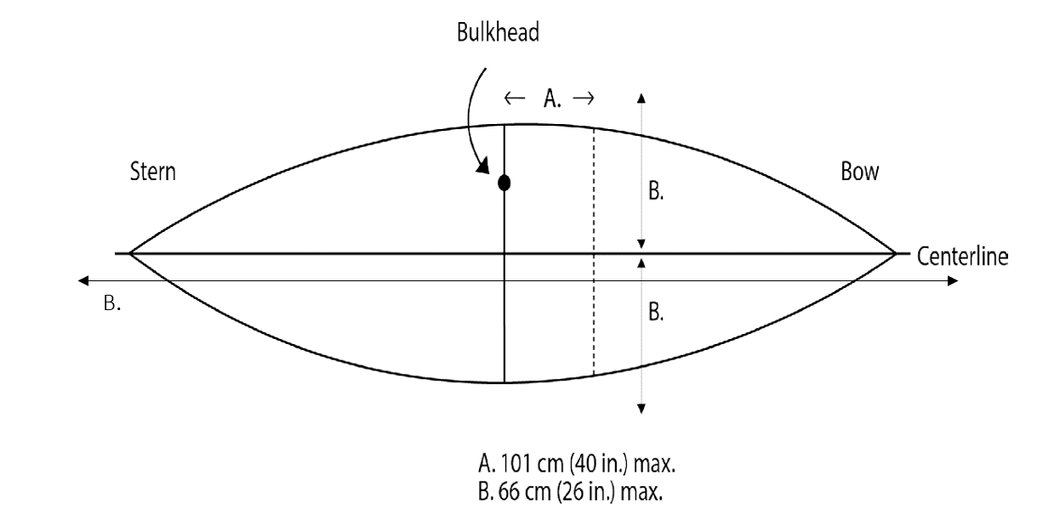

The Qualifying Configuration
The qualifying configuration (See Figure 2) is electric only and may be modified to permit better handling at high speed, but no component, which change the buoyancy or stability can be removed. The boat should be at its heaviest race configuration when qualifying.

Figure 2

Qualifying
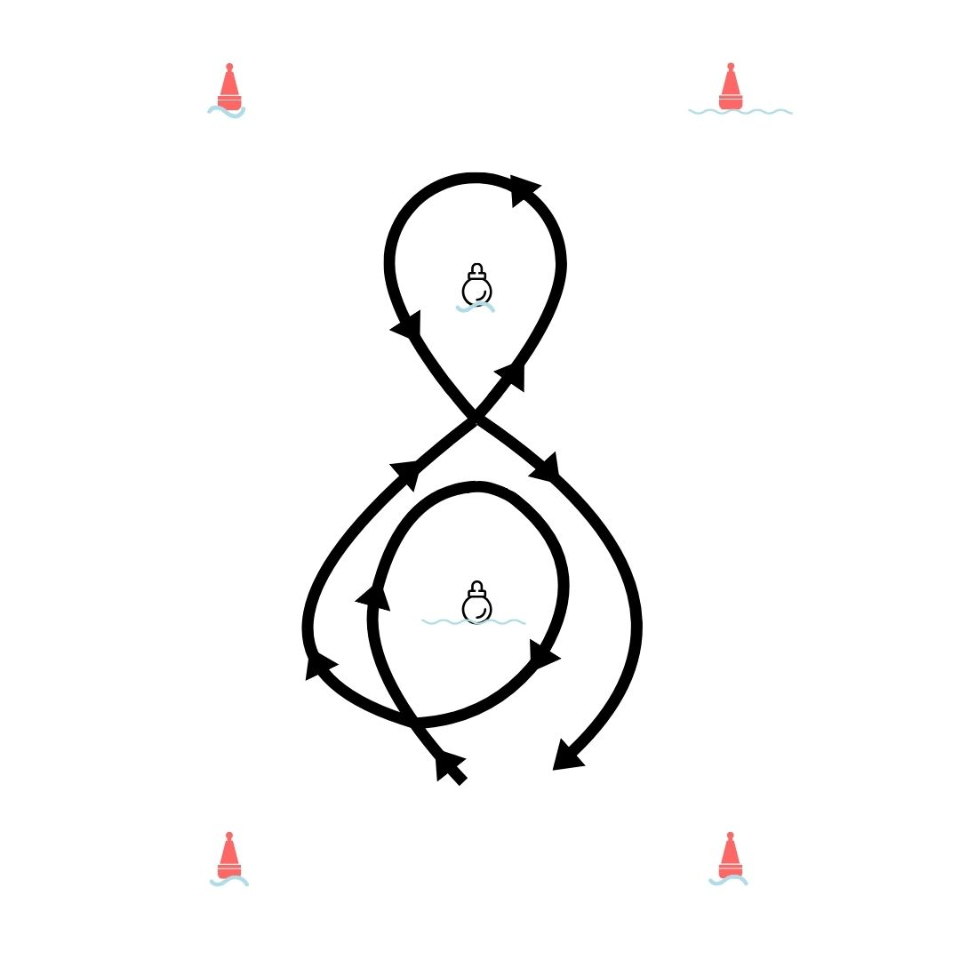

The Endurance Configuration
Solar panels must be in place and have a minimum one sun output of 100 watts and a maximum output of 320 watts. The endurance configuration (see Figure 3) will be a closed clockwise loop and is likely to be irregular in shape due to the shoreline and spectator areas.

Figure 3

Endurance

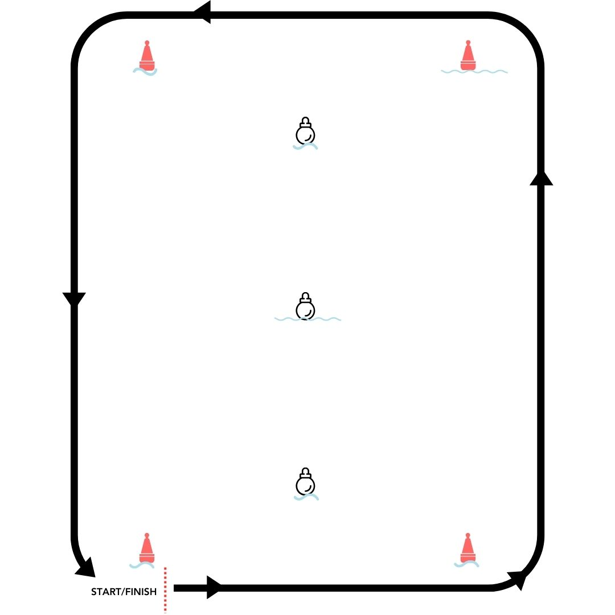

The Sprint configuration
The sprint configuration (see Figure 4) is battery power only and is a straight line with a fixed distance of 80 yards.

Figure 4

Sprint

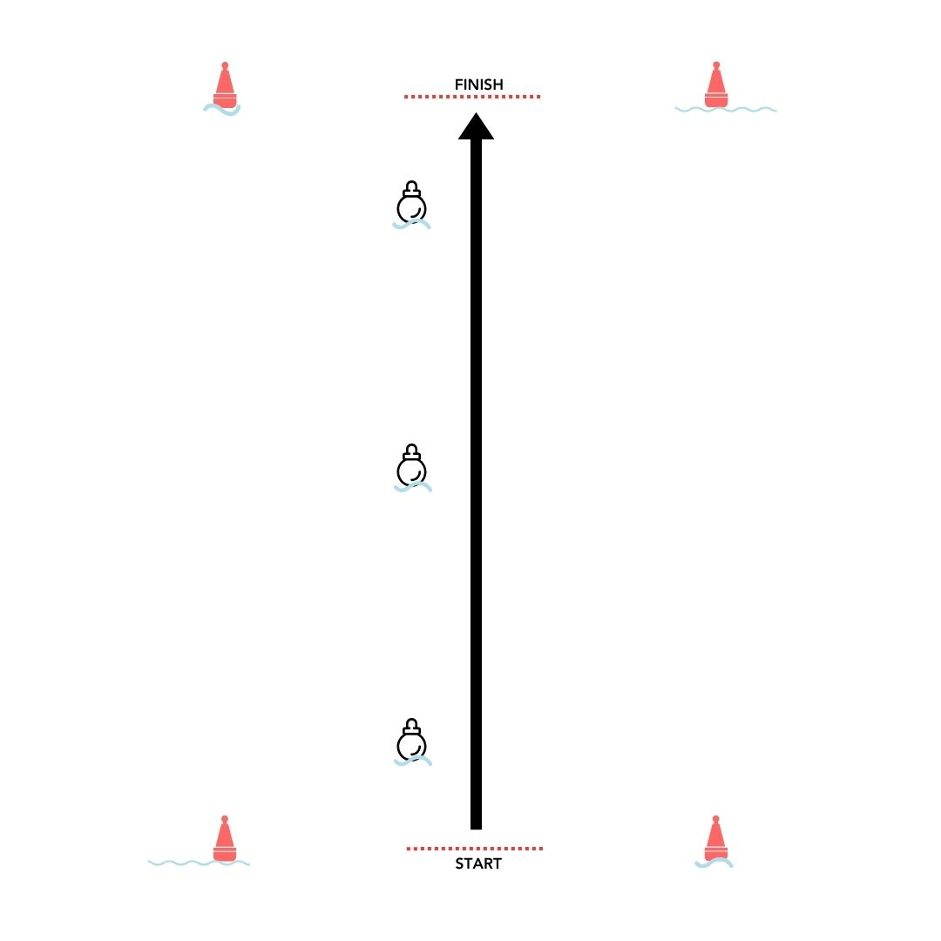

The Slalom Configuration
The course will be positioned as described in Figure 5.

Figure 5

Slalom

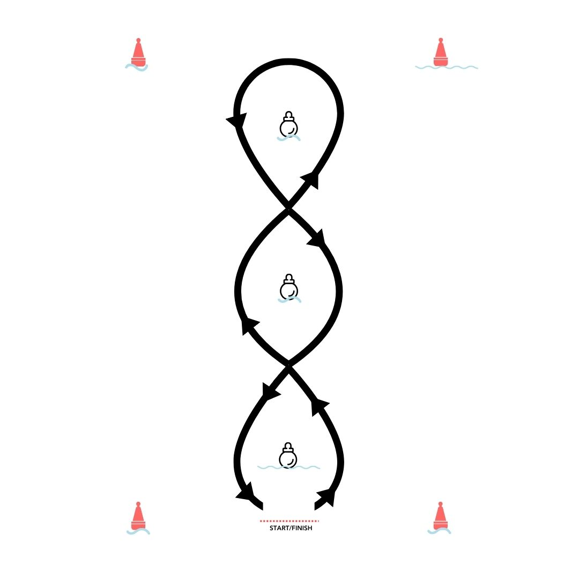

    - Modifications: A skeg, fin or keel, referred to as structure must meet the following requirements.

      - The structure must be planar or flat in nature with the thickest part of the structure attached to the bottom of the boat with the structure tapering as it extends away from the boat (similar to a surfboard fin). Structures such as a “bulb keel” or “Tunnel Fin” which dramatically vary the thickness or cross-sectional area of the structure will not be allowed.
      - The structure must be mounted vertical with respect to the bottom of the boat. In this configuration the structure will be perpendicular to the surface of the water when the boat is at rest. No horizonal components such as wings or foils which attempt to provide lift or thrust to the boat will be allowed as part of the structure.
      - The maximum vertical length of the structure will be less than 25.4 cm (10 in) measured from the bottom of the boat to the tip of the skeg, fin or keel.
      - The number of structure attachments will be limited to a maximum of three, however the total square inches shall be 76.2 square cm (30 square in) or less, so if three equal size structures are proposed each must be less than 25.4 square cm (10 square in).
      - The total square inches of all such attachment(s) will be limited to 76.2 square cm (30 square in) in profile (i.e. from the side view). Because these structures often have unique curvatures it is up to each team to prove that its design is less than the length limit.

    - Stem (bow and stern): The stem may be sanded or shaved to a minimum of 2.54 cm (1 in,) radius.

    - Solar Array Output – All participants must have their solar collection devices checked to verify that the output does not exceed 320 watts under normal one sun conditions. Inspections will occur at the discretion of the technical inspectors.

Entries

  - Team Member Eligibility - Anyone who is currently attending the participating school as a full-time student is eligible to serve as a team member.

  - Skipper Eligibility - The skipper must be a team member, must be at least 14 years old and must submit the mandatory waivers.

Venue

  - Site - The site for the Event is:
Yucaipa Regional Park
33900 Oak Glen Road
Yucaipa, CA 92399
- Regulations

  - Slalom – All boats will be considered “battery powered” for the Slalom. Allowed battery capacity will be 57 lbs. total, the same as for the Sprint Configuration (Refer to Rule 8.3). A maximum of two sets of batteries will be inspected and permitted for use in the Slalom event. The boat will be always operated only by a skipper, remote control operation is not allowed.

  - Solar Endurance - All boats will be powered by direct and stored solar energy. The maximum output of the solar array under normal one sun conditions will be 320 watts. The minimum output under normal one sun conditions is 100 watts. The boat is allowed to carry 25.8 kg (57 lbs.) of lead acid or gel cell batteries. A maximum of one set of batteries will be inspected and permitted for use in the Endurance event. The boat will be always operated only by a skipper, remote control operation is not allowed.

  - Sprint - All boats will be considered “battery powered” for the Sprint, the solar panel(s) may be removed. The boat is allowed to carry 25.8 kg (57 lbs.) of lead acid or gel cell batteries. A maximum of two sets of batteries will be inspected and permitted for use in the Sprint event. The boat will be always operated only by a skipper, remote control operation is not allowed.

  - Technical Specifications - Penalties may be assessed if a boat does not meet any of the technical specifications, by the Event officials.

    - Length – With exception to what is permitted in Section 5.2.4, only the boat sign and the rudder blade may extend beyond edge of the boat.

    - Width - Nothing may extend more than 66 cm (26 in) beyond the boats deck edge and measured perpendicular to the centerline of the boat. (See Figure 1, “B”)

    - Height - The maximum allowable height above the waterline is 1.5 meters (4 ft, 11 in). This height can never be exceeded during the events. This does not include the boat number sign.

    - Depth - No restriction beside the maximum vertical length of a skeg, fin or keel. (Refer to 5.2.5). An excessive depth may make the boat awkward to handle near shore and may increase the likelihood of encountering underwater obstacles.

    - Cross Sectional Area - In profile, the fixed area (such as the hull) is unrestricted. The solar array may be fixed or may be in the form of one or more movable panels.

    - Weight – The maximum total weight of the craft in any configuration shall not exceed 450 lbs. Crafts will be weighed during technical inspections.

  - Materials - Teams are encouraged to be creative in the selection of materials. The only restrictions are:
1) flexible materials are not allowed to create a sail, 2) any materials that would pollute the water are not allowed.

  - Power - Sunlight and battery is the only power source that shall be used for propulsion. Wind and human power are not allowed. The sunlight may be direct (received onboard during the Event using
photovoltaic panels) or may be stored in approved batteries. Batteries can be charged only from the inspected solar panels, which may not have a one sun output greater than 320 watts. At no time during the Event may competition batteries be charged with any source other than the approved solar panels.

    - Storage of Solar Radiation - All boats in the Event will be allowed to store solar energy in their batteries at any time during daylight hours from the time of registration to the completion of the last competition. Battery chargers are NOT to be used on propulsion batteries after they are inspected but may be used on the supplemental batteries.

    - Supplemental Batteries (Auxiliary Batteries) - Supplemental batteries are required for safety reasons. These batteries may not provide propulsion nor directly enhance performance. Its own supplemental battery must power the bilge pump. Other acceptable uses include relays, radio, telemetry, stability control, and memory devices. At Technical Inspection, such batteries, and the devices they are in, will be checked to assure that no possibility exists to convert the power into propulsion for the boat. The supplemental batteries are not limited to lead-acid technology and must be securely fastened to the hull.

    - System Voltage - May not exceed 52 VDC or alternating current root mean square (AC RMS).

    - Source Voltage - May not exceed 24 VDC nominal value (usually 2 batteries). A maximum open circuit voltage of 52 VDC for the photovoltaic charging devices is allowed.

“Energy Storage Advice” In addition to the storage of solar energy in the battery, energy may be stored using other devices such as capacitors or flywheels. Storage of energy may begin at the “on deck” time.

  - Visibility - The skipper must have unobstructed vision forward and at least 100 degrees to either side.

  - Stability - Due to time constraints, it may be necessary to conduct events in less-than-ideal conditions. Since safety is vital, the stability of the boat will be tested by placing 10 kg. (22 lb.) at the sheer line (outer edge at the beam) with the skipper stationary in the normal operating position. Boat must not heel more than 15 deg. Skipper must remain centered with hands/feet in normal position.

  - Throttle - In the Endurance event, the throttle control assembly mechanism on the boat must be free moving and when released, must return to the zero-current position (Propulsion System Cease Operating). A “Kill switch with Tether” must be incorporated in all the events.

  - Ballast Carrier - The ballast container must be designed in a manner that the ballast will fall out of the boat if it capsizes (turns over 180 deg) or adequate flotation must be provided for the ballast.

  - Automatic Bilge Pump - An automatic electric bilge pump that is powered by a supplemental battery is required. The pump must have a minimum rating of 1,890 litter per hour (500 GPH), such as a rule-mate model #500 pump sold by West Marine or equivalent. The bilge pump must be located aft of the bulkhead, and the discharge hose may not be smaller than the outlet on the pump. The hose must be secured to the hull (facing downwind) to ensure that the discharge goes overboard. The battery for the bilge pump must be of sufficient capacity to power the pump for a minimum of two hours and may not be used to power any other devices. When needed the bilge pump can be switched out for safety.

  - Covers and Shields - All steering linkage must be shielded (plastic tubing’s, split loom spiral wrapped etc.) from contact with the skipper. Boats propulsion revolving parts must be covered greater than 0.25-inch-thick plywood, greater than 0.185-inch metal sheets or equivalent materials to prevent potential injury to skipper. Skippers that have hair that is longer than shoulder length must have it secured in a ponytail or under a hat.

Electrical

    - Motors- There is no limit to the number of motors used by a team. However, all boats are to include all team equipment (does not need to be hooked up) when weighed at their heaviest configuration on Friday during initial technical inspections.

    - Shock Hazards - All exposed conductors operating at or greater than twenty-four (24) direct current/alternating current (DC/AC) volts must be properly insulated.

    - Battery Type - Only secondary (electrically rechargeable) batteries are permitted. Fuel cells, primary batteries, or mechanically rechargeable batteries will not be approved. Each team is responsible for supplying their own batteries. The batteries must be commercially available, lead-acid or gel cell unmodified with their weight consistent with the Rules. Boat can carry a total battery weight of not more than 23.8 kg (57 lb.). Batteries must be stock (as manufactured) in every sense. The battery modules may not be modified in any manner, including the addition of electrolyte, additives, case modification; or plate addition, removal, or modification. Manufacturer’s data, which includes battery weight and manufactures specification data sheets (MSDS), must be available at Inspection time. Batteries will be weighed during Inspection. 3 sets of batteries will be allowed for the weekend of the Event. The SoCal STEAM Committee recommends Solar Re-Generation for re-use of batteries. Overweight batteries will be confiscated until after the competition.

    - Battery System - Batteries must be enclosed in separate battery boxes and securely anchored to the hull aft of the bulkhead. This must be done in such a manner that the battery boxes and their batteries remain in place if the boat capsizes. All electrical cables must use proper gauge wire to expected system currents.

    - Battery Switch - All boat must have a battery switch wired to disconnect all power to the motor. The battery switch must be placed within reach and visual line of sight of the skipper during operation of the boat. The battery switch must be able to interrupt full load current. The battery switch must have a minimum rating of 350 amps continuous, such as the Blue See System Model 9004E.

    - Main Fuse - A separate fuse (not a circuit breaker) must be in series with the main battery connection at all times and the rating must not exceed 350 amps.

    - Other Fuses - Accessories, gauges, and control circuits must be fused appropriately for the wire size used.

  - Radios - There is no restriction on the type or frequency of voice or telemetry radio communication with the competition boat, but voice radio communication from the Launching Site is required. This will be the responsibility of each Team. Teams who are not in possession of radios at the start of their race, will not be permitted to participate.

  - Skipper Cockpit - The skipper’s cockpit must provide for the skipper’s unassisted exit within 5 seconds in case of emergency. The five (5) second exit, as well as the function of the dead-man’s switch, will be checked during Inspection/Qualifying.

    - Harnesses - No harnesses or restraints to hold the skipper in place will be allowed.

    - Safety - The cockpit area will be inspected for hazards and compliance with the Rules during the Technical Inspections and in the Staging and/or On Deck areas.

    - Power Indicator Lamp- The power indicator lamp must be located on the boat deck above the propeller area. The power indicator lamp must be a flashing LED that is visible in direct sunlight. Whenever the battery switch is providing power to the propulsion unit, the power indicator lamp must be illuminated and flashing.

Fasteners

    - Drive Train - All fasteners associated with the boat’s drive train must be equipped with either locking nuts, double nuts, or nuts secured with safety wire or cotter pins. Thread locker may be used in areas of difficult accessibility but must be accompanied by a written statement of application by the Team’s Faculty Advisor.

    - Batteries –Batteries must be covered, and the assembly must be secured to the hull. Acceptable safety of the battery assembly is at the discretion of committee technical inspectors. Teams must submit a diagram of the battery assembly prior to Event inspections for technical inspector review. Batteries must be secured with a strap not less than 3.1 cm (1 1/4 in) width, or other hold-down device, that will not allow the battery to come loose if the boat capsizes. Velcro is not acceptable. Batteries must be secured with 1¼ inch strap or metal clasps to secure the battery box or lid.

    - Solar Panels - Each panel, with or without a frame, must be attached with a mechanical fastening to the hull. The design should consider the possibility of gusty winds during the events. In addition, a lanyard must be attached from each solar panel to a secure member of the hull or a frame that attaches to the hull. The lanyard must be strong enough that it will not break if the panel should go into the water while the boat is moving.

Safety Equipment

Life Preservers – A life preserver, USCG approved Type I, II, or III, must be worn by all Skippers.

Buoyancy of Boat - Sufficient flotation must be provided on board so that the boat cannot sink. Verification calculations must be provided at the Technical Inspection and submitted in writing at Registration. A 20% safety factor must be included in the calculations.

Towing - A bow eye must be fastened to the bow of the boat. All boats must carry a minimum of 5m (5.6 yd) of towing line and 3/8” minimum in diameter, which will be provided by each participating team. A floatation device must be attached to the towing line to prevent the line from sinking when deployed and to facilitate throwing of the line for assistance.

Signal Devices - Two signal devices must always be carried on board the boat.

Audible- A sound producing device (a pressurized air can is acceptable)

Visual- An orange (“skier in the water”) warning flag. This flag must be displayed in the event of a breakdown. A socket for the flag must be provided to free the skippers hands to paddle the boat. Teams who are not in possession of radios at the start of their race, will not be permitted to participate.

Paddle - A paddle, greater than 60 cm (23.6 in) long with a blade greater than 13 cm (5.1 in) wide, must be on board at all times. The skipper will demonstrate how he will propel the boat with the paddle during Technical Inspections.

Fire Extinguisher - A U.S. Coast Guard approved fire extinguisher with a minimum capacity of 0.45 kg (1 lb.) must be carried on the boat.

Propeller Warning - Vertical stripes 2 inches wide shall be installed (or painted) on the hull from the deck to the water line eight inches forward and aft of the propeller location. The stripes should display the words “Warning” or “Propeller area”.

Safety Plan- A safety plan describing the methods for launching and retrieving a boat in a safe manner must be provided at time of inspection. See Appendix G.

Competition Events

  - Inclement Weather – In the event of weather posing a safety threat during the races, all team boats will be required to leave the water until it’s deemed safe to resume at no point or time penalty to the teams. Tow-in will be allowed without disqualification. The decision of what qualifies as inclement weather will be determined by the SoCal STEAM Committee and the lifeguard on duty.

Endurance-Teams that need to leave the water during the Endurance race, will need to disconnect the power from their solar panels. Battery replacements will not be allowed.

  - Skipper’s Meetings – An open meeting will be held each day, Friday, May 1 after dinner, Saturday, May 2 and Sunday, May 3 at 8 a.m., unless otherwise posted, before the day’s events. Meetings are mandatory. Failure to do so will result in a penalty of 5% to the overall score for each missed meeting.

  - Start and Finish – Slalom and Sprint events will commence from a standing start. The finish is indicated by the bow crossing the appropriate mark. Endurance events will commence at the teams designated start time from the indicated starting point and finish at the end of 90 minutes.

  - Course - Courses for the on-the-water events are defined as follows:

    - Qualifying: The primary purpose of Qualifying is to determine the eligibility of teams to participate
in the Event. Teams must pass Technical Inspection prior to attempting to Qualify. Qualifying will be used to test the safety, seaworthiness, and handling of each boat. The qualifying course is shown in Figure 2.

    - Slalom – The course will have three markers. Each team must be in the water at their scheduled time and has 20 minutes to complete the course. Teams may do two heats within their timeframe. The shorter time will be used. A battery swap between heats is permitted. Boats are not required to carry solar panels. Boats will be required to return to launching site without being towed. Paddling is allowed. Boats must veer to the right around the first buoy (Figure 5). If a team is delayed in entering the water due to Event Committee delays or another school, the delayed team’s 20-minute time frame begins when they enter the water. Teams not in the water at their appointed time may still compete but will incur a five-point penalty and must be out of the water by the end of their scheduled time.

    - Sprints - Sprints will be held over a straight-a-way course. Boats are not required to carry their solar arrays during the Sprint event. Each team has 20 minutes to complete two heats. The shorter time will be used. A battery swap between heats is permitted. Boats will be required to return to the launching site without being towed. Paddling is allowed. If a team is delayed in entering the water due to Event Committee delays or another school, the delayed team’s 20-minute time frame begins when they enter the water. Teams not in the water at their appointed time may still compete but will incur a five-point penalty and must be out of the water by the end of their scheduled time.

    - Endurance - The event will be held over a closed course not exceeding 2 km in length (2180 yds). The course will be run in a clockwise direction. All entries must carry their solar panels, as inspected, on board during the event. Any changes in the solar panels must be re-inspected and re-approved before competing. Towing will be allowed if there is a mechanical failure, however the team’s time will continue to run and team must restart their last unfinished lap at the starting line.

  - Overtaking - Once an overtaking boat establishes overlap (the bow breaks an imaginary perpendicular plane across the stern of the overtaken boat), the overtaking boat has the right-of- way and must use their audible device to let the overtaken boat know.

    - Overtaking on a Straightaway (see Figure 6) - Boat A is about to be overtaken by Boat B. Boat B must alert and inform boat A as to their intention to overtake on the starboard or port side. One short whistle blast signifies overtaking on starboard side and two short whistle blasts signifies overtaking on port side. Teams who do not provide their own whistles will be subject to point deductions.

Figure 6

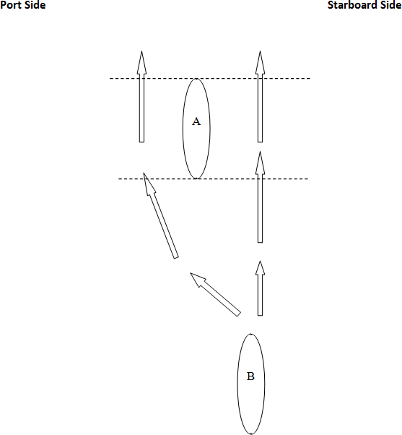

    - Overtaking at a Buoy (See Figure 7) - If Boat A cross’s imaginary line C before Boat B, Boat A has the right-of-way of making a starboard turn as shown. Boat B cannot interfere with Boat A’s starboard turn. If Boat A makes a wide starboard turn as shown, Boat B may make a tighter turn around the buoy if Boat B does not impede Boat A.
If Boat B crosses imaginary line C before Boat A cross’s imaginary line D, Boat B has the right of way to go around the buoy and Boat A must proceed in a straight line.

Figure 7


D
A

C


B

  - Buoys - The first boat to reach a buoy has the right-of-way until the stern of the boat has cleared the buoy (see 9.5.2, Figure 7). If a boat strikes a buoy, a penalty will be assessed (see 12.2.3, 12.3.2 and 12.4.2).
Note: Red and White Buoys will be used for all race configurations as shown in Figures 2, 3, 4 & 5. All other buoy colors will be used to indicate impediments within the lake.

  - Leaving the Course – In the Endurance event, if a boat leaves the course for any reason, it must re- enter at the same point or further back.

  - Boat Staging - All boats will be staged overnight, each night, for the duration of the Event, in the paddock/staging area to prevent “all-nighters”, which could cause safety concerns. Impound will begin after qualifying on Friday, May 2nd and will be from 6 p.m. to 7 a.m. daily. No components may be taken from the boat staging parking lot area. If a new component is acquired during the impound time, it must be inspected before being installed in the boat.

Scoring

  - Scoring and Results – The results of each day’s events will be available no later than the following day’s morning meeting. The results of the final day’s events will be announced and posted at the final awards ceremony.

Overall Scoring- Total possible points is 1000. The following overall scoring system will be used.

    - Technical Inspections – Each team will be awarded points for completing certain technical items that do not need to be changed or improved. The most points a team can earn for technical inspections is 50 points. The technical sheet is Appendix E.

    - Technical Reports – The technical reports consist of two (2) written reports: (1) the Drive Train and Steering Report and (2) the Electrical and Solar Array Report. Each report must be submitted as two individual reports through the SoCal STEAM website. Reports are each worth 100 points. Please see Appendix C for grading criteria, due dates, and rules for submitting reports.

    - Public Service Announcement – Students will need to prepare a Public Service Announcement (PSA) on the topic given. The PSA content and presentation can receive a maximum of 300 points. The following point distribution and guidelines will be used:

 | Weight (Points) | Time Limit (Seconds)
Content: | 200 | 180
Presentation: | 100 | 90
Total: | 300 | 270

PSA Content will be scored prior to the Event by outside evaluators. PSA Presentations will occur during the Event and scored by guest judges. Scores for both Content and Presentation will be averaged when multiple evaluators are used. Penalty for exceeding time limit(s) will result in a 5-point deduction from total PSA points.
An outline of PSA content will be due February 25, 2026. Final PSA’s will be due March 26, 2026. Both shall be uploaded through the SoCal STEAM website. Final PSA’s will be saved as SCHOOL NAME and Report Name (ex: solarhighschool_PSA.mov). Files need to be in .mp4 or .mov. format. Late submittals of PSA videos will receive a 10% per day deduction in total PSA points. Please see Appendix D for scoring rubric(s).

    - Slalom – The Slalom race is worth a maximum of 125 points. Each team will be allowed to complete this race twice and take the better of the two times. The best time for the team will be entered into this formula below:

Winner’s Time | X | 125 | = | Points Awarded
Your Time

Your Time/ Winner’s Time *125 = Points Awarded

Please Note: If either race cannot be completed the team will be awarded no points for this event.

    - Sprint - The Sprint race is worth a maximum of 125 points. Each team will be allowed to complete this race twice and take the better of the two times. The best time for the team will be entered into this formula below:

Winner’s Time | X | 125 | = | Points Awarded
Your Time

Your Time /Winner’s Time *125 = Points Awarded

Please Note: If either race cannot be completed the team will be awarded no points for this event.

10.2.6 Endurance Event – The Endurance race is worth a maximum of 200 points. Each team will have1 ½ hours to see how many laps they can complete during that time. When time expires, the last complete lap will be counted. The number of laps completed will be inserted into the following formula:

Most Laps | X | 200 | = | Points Awarded
Your Laps

Your Laps/Most Laps*200 = Points Awarded

Graphics

  - Boat Number Signs - Each boat will have a boat number. Each team will be provided with a base and an “L” bracket for their boat number sign. It, or a satisfactory substitute, must be mounted in a manner which will allow for the proper display of the sign. All participants will be provided physically similar signs. These signs and “L” brackets may not be modified. The sign will not be included in the dimensions of the boat.

  - Event Logo - The Event identification and logo must be displayed at all times. These are part of the boat number sign.

  - School Name - School names on the boat are optional but recommended.

  - Sponsor Identification - Sponsor identification must be displayed on both sides of the boat, above the waterline, at all times. Teams must display sponsor identification on both sides at the bow and stern of each boat. The participant must provide an area to apply decals of at least 24 inches in length aft of the bow stem and forward of the stern stem. This area will be a solid color that will contrast with the logos provided. (This allows approximately 9 feet in the center area on each side for your school
name.) In addition, all materials produced by teams, which use the SoCal STEAM logo, must be approved by the SoCal STEAM Committee before being printed and distributed.

  - Inappropriate Graphics – SoCal STEAM reserves the right to disapprove any graphics.

- Penalties - Any team failing to comply with the rules, as stated herein, may be penalized. Officials are required to record all instances of unsafe conduct, and penalties will be assessed as follows. Officials may assess penalties ranging from 5% of total Event points to total disqualification for a Team’s failure to comply with any regulations.

  - Deadline Penalties- Missing of any deadlines may result in a 5%-point deduction penalty from that category unless noted differently. The SoCal STEAM Committee reserves the right to waive the penalty if it is determined the deadline could not be met due to an action or failure to act on the SoCal STEAM Committee’s behalf or an unavoidable circumstance.

Qualifying Penalties

    - Unprepared for Qualifying- If a team has not qualified or is not in the water by their allotted time (1 hour), the team will receive a 5% penalty on their Technical Inspection sheet.

    - Leaving the Course - If a boat leaves the Qualifying course, the boat has not qualified.

    - Striking a Buoy - If a boat strikes a buoy, a five (5) second penalty will be assessed.

    - Mechanical/Electrical Failure – The boat shall not be repaired in the water. Repairs are to be made at the paddock or on the shore, adjacent to the water. The boat shall be inspected (electrical/mechanical) before returning to the event. The re-run must be done on the same day and before 5:00 pm of the day or be disqualified from the event.

    - Disturbing Official Battery Markings - When batteries are inspected, they will be given official tags. These markings must not be disturbed. Competitors are allowed to use only the batteries inspected for their boat. Officials may assess penalties ranging from fifty (50) points to total disqualification.

    - Obstructive Boating - Any Team that operates their boat in a manner that impedes the progress of another boat or risks the safety of another boat or of their own will receive a minimum penalty of fifty (50) points or may be disqualified at the discretion of the Officials.

Slalom and Sprint Penalties

    - Leaving the Course – If a boat leaves the slalom course, the boat has ended its run and may not re-enter the course or finish.

    - Striking a Buoy – If the boat strikes a buoy and remains in its designated course. A five (5) second penalty will be assessed.

    - Mechanical/Electrical Failure – Boats shall not be repaired in the water. Repairs are to be made at the paddock or on the shore, adjacent to the water. The boat shall be inspected (electrical/mechanical) before returning to the water. Teams may re-run their heat within their allotted 20-minute timeframe. Note: A battery swap between heats is permitted to occur while the boat is in the water as long as there is no mechanical/electrical failure associated with the swap.
    - Disturbing Official Battery Markings Refer to Rule 12.2.5

Endurance Penalties

    - Leaving the Course – If a boat leaves the endurance course, minor modifications are allowed to be made and boat may return to course to finish race. Once the boat leaves the course a SoCal STEAM Committee member must be notified. If the boat needs minor modifications and
wants to return to the race, a technical inspector has to approve all modifications being made. Please note: while modifications are being made to the boat, the clock will continue to run.

    - Striking a Buoy – If the boat strikes a buoy and remains in its designated course. A five (5) second penalty will be assessed.

    - Mechanical/Electrical Failure-- The boat shall not be repaired in the water. Repairs are to be made at the paddock or on the shore, adjacent to the water. The boat shall be inspected (electrical/mechanical) before returning to the event. Teams may return to the water within their 90-minute timeframe, however, the last, incomplete lap will need to be re-ran.

    - Disturbing Official Battery Marking – Refer to Rule 12.2.5

    - Obstructive Boating - Any team that operates their boat in a manner that impedes the progress of another boat or risks the safety of another boat or of their own will receive a minimum penalty of one lap per infraction or may be disqualified at the discretion of the Officials.

    - Failure to Yield to Right-of-Way – Any team failing to allow right-of-way when being overtaken by another boat will be penalized a minimum of 0.5 laps per infraction.

  - Paddling - Using paddles or oars to power the boat during any competitive event (other than to avoid becoming a safety hazard, or to move from the race lanes into the buoys during the Endurance race) will result in automatic disqualification.

  - Skipper’s Meetings – Attendance at Skipper Meetings are mandatory. Any team that fails to be properly represented (1 teacher or advisor and 1 skipper) will not be able to provide input to changes made during meeting.

  - Conduct - Officials may assess penalties ranging from ten (10) percent penalty of overall score to total disqualification for improper conduct. Such conduct may include, but is not limited to, improper language, failure to listen to officials during any workshops and/or event (including at campground area) and obscene gestures.

- Prizes and Awards – The SoCal STEAM Committee will recognize all Teams’ participation. In addition, the following awards will be presented:

  - Race Awards – For each competition 1st, 2nd, 3rd place awards will be presented to the teams that demonstrated the best performance.

  - Overall Awards - Overall 1st, 2nd, 3rd place winners will be determined by a formula
which includes: technical reports, inspection reports, PSA content/presentation and the Endurance, Slalom and Sprint races.

  - Other Awards - Other awards may be presented at various times during the Event, including the June Hayes Sportsmanship Award (Appendix F) and Craftsmanship Award, which is determined by the Craftsmanship grading rubric (Appendix E).
  - Award Ceremonies - An awards ceremony will be held on Sunday, May 3, 2026, following the final event.

- Procedures - To assure that all competitors are in compliance with the Rules during the competitions, an impound area has been established. This area is for boats that are ready for the next event. No one is allowed in the area except for Event officials. There are some safety concerns that will be checked and are subject to penalty. This, along with the “staging” area, is intended to expedite the conduct of the competitions, especially the Sprint events. All Rules and procedures are written with the safety of the participants and spectators in mind.

  - Staging - All competitors must be in the staging area at ½ an hour before the competitions. Technical inspections take place at the staging area. Charging of the battery pack may occur during this time.

  - Swimmers - At no time during Qualifying, Slalom, Endurance and Sprint races will a swimmer be allowed in the water to assist a boat in any manner.

  - Protective Wear - Protective eyewear must always be worn by anyone who is handling batteries. Closed toe footwear is always required for all participants. For the safety of the students, all participants must wear closed toe footwear when going in the water or working in staging area. Participants required to enter the water at any time will not be permitted to do so without proper footwear or lifejackets.

  - Rule Interpretation - Should there be a question regarding the meaning of Rules, the participating team will file their question in writing to the current SoCal STEAM Committee Chair or Vice-Chair.

  - Boat Removal - Boats must be removed from the water if extensive repair work is required. Only minor repairs will be allowed on the water and must be done outside the course area. Boats left in the water must be inspected before they compete in the next event. Any student assisting with boat removal must wear closed toe shoes. To ensure safety of all students, life jackets must be worn anytime they enter the water.

- Advertising, Promotion and Publicity - All advertising, sales promotion, and publicity material produced by the Teams or their sponsors concerning or referring to the Event shall refer to the Event as SoCal STEAM Challenge. By entering the Event, all teams shall agree to the use of, without compensation, their names and photographs in any publicity material that may be issued by SoCal STEAM.

APPENDICES

Appendix A

SoCal STEAM Challenge
ASSUMPTION OF RISK – WAIVER FOR PARTICIPANTS
In consideration of being allowed to participate in the SoCal STEAM Challenge and activities, the undersigned acknowledges, appreciates, and agrees that:

- The risk of injury from the activities involved as a participant can be significant, including the potential for permanent paralysis and death, and while rules, equipment, and personal discipline may reduce this risk; the risk of serious injury does exist.
- I knowingly and freely assume all such risks, both known and unknown, even if arising from the negligence of the releasees or others and assume full responsibilities for my participation.
- I certify that I am physically fit and have sufficiently prepared for participation in the event activities. I certify that I have no health-related reasons or problems which preclude my participation in this event,
- I affirm that neither I, nor any member of my household, has had symptoms or has been diagnosed with COVID-19 within the past 10 days.
- I affirm that I have not demonstrated any symptoms of or to my knowledge have been exposed to any communicable diseases (including but not limited to the COVID-19 virus) within the past 10 days. I also affirm that I will adhere to all safety precautions communicated by the coach/school administration before and during the event.
- I agree to abide by all rules and regulations promulgated by the event holders, sponsor, and organizers of the event.
- “I, for myself and on behalf of my heirs, assigns, personal representatives and next of kin, hereby release, hold harmless and indemnify officials, agents and/or employees, other participants, sponsoring agencies, sponsors, advertisers, owners and lessors of premises used to conduct the event (collectively, “Releasees”), with respect to
  - my participation in the event activities; (2) any and all injury, disability, death, or loss or damage to person or property, whether arising from the negligence of the Releasees or otherwise; and (3) the condition of the premises where the event occurs. I also agree that I, my heirs, assigns, personal representatives and next of kin will not make a claim against, sue or attach the property of any Releasee in connection with any of the matters covered by this release and indemnity.”

Print Participants Name Participant’s Signature For Participants of Minority Age (Under 18 years)
This is to certify that I, as parent/guardian with legal responsibility for this participant, do consent and agree to his/her release as provided above of all the Releasees, and for myself, my heirs, assigns, and next of kin. I release and agree to indemnify the Releasees from any and all liabilities incident to my minor child’s involvement or participation in these programs as provided above, even if arising from their negligence.

_
Parent/Guardian Signature Date

Photo Release: I understand that this event, or related activities, may be photographed. I agree to allow my photo, video or film likeness to be used by the event holders, producers, sponsors, organizers and assigns.

Print Participants Name Participant’s Signature

Parent/Guardian Signature Date


Appendix B

SoCal STEAM Challenge
Statement of Swimmers Ability
In consideration of being allowed to participate in the SoCal STEAM Challenge and activities, the undersigned acknowledges, appreciates, and agrees that:

- Pursuant to the SoCal STEAM Challenge Rules Section 4.11 and 5.2.2, a brief test of 50 meters swimming distance and treading water for 1 minute for the swimming ability of skippers and any other team members who may skipper the boat. Participants will not be allowed to use any flotation equipment or any propulsion device such as “flippers” to assist them.
- This activity shall be conducted by the Team’s advisor.

Print Participants Name Participant’s Signature

Print Advisor’s Name Advisor’s Signature For Participants of Minority Age (Under 18 years)
This is to certify that I, as parent/guardian with legal responsibility for this participant, do consent and agree to his/her release as provided above of all the Releasees, and for myself, my heirs, assigns, and next of kin. I release and agree to indemnify the Releasees from any and all liabilities incident to my minor child’s involvement or participation in these programs as provided above, even if arising from their negligence.

_
Parent/Guardian Signature Date

TECHNICAL REPORT RUBRIC
School: Team Number: Report Type: Drive Train & Steering
Electrical & Solar Array

*Judge: Please select ONE a, b, c & d (if applicable) from each of the 3 columns.
Submitted  On  Time | Discussion and Content  a-Physical Phenomena b- System Description  c- Testing Procedures | Analysis and Evaluation  a-Data & Analysis b-Tables & Charts | Written Presentation  a-Report Layout b-Introduction  c- Grammar, Spelling, etc. d- Conclusion
On Time:  10 Points | Level 4 - 4 points each  - Very thorough discussion of Physics, Math and/or Engineering concepts, including advance concepts if used.  - Very complete description of system including diagrams or pictures  - Very complete description of experimental/testing procedures | Level 4 - 4 points each  - Thorough description of data analysis, any subsequent calculations performed or other operations to explore the data.  - Highly relevant tables, graphs, charts, etc. | Level 4 - 4 points each  - Cover page, Title Page, Table of Contents, Team list with roles included  - Introduction: Very clear and very thorough introduction, including background information  - Proper grammar, spelling and sentence structure used throughout the paper  - Conclusion: Very clear and very thorough conclusion, including recommendations
Late:  5 Points | Level 3 - 3 points each  - Effective discussion of key concepts, including advanced concepts if used.  - Effective description of system including diagrams or pictures  - Effective description of testing procedures | Level 3 - 3 points each  - Good description of data analysis  - Tables, graphs, charts, etc. useful to report | Level 3 - 3 points each  - One of the following missing: Cover page, Title Page,  Table of Contents, Team list with roles included  - Effective introduction, including background information  - Some errors in grammar, spelling, etc.  - Effective conclusion, including recommendations
No Credit:  0 Points | Level 2 - 2 points each  - Limited discussion of key concepts, including advanced concepts if used.  - Limited description of system, with few diagrams or pictures  - Limited description of testing procedures | Level 2 - 2 points each  - Data analysis poorly described or not used  - Graphics not well used to support report | Level 2 - 2 points each  - Two of the following missing: Cover page, Title Page,  Table of Contents, Team list with roles included  - Incomplete introduction, with no background information  - Several errors in grammar, spelling, etc.  - d. Incomplete conclusion, missing recommendations
 | Level 1 - 1 point each  - Little or no discussion of key concepts, including advanced concepts if used.  - Little or no description of system  - Little or no description of testing procedures | Level 1 - 1 point each  - Data analysis not included  - Graphics do not support report | Level 1 - 1 point each  - Three or all of the following missing: Cover page, Title Page, Table of Contents, Team list with roles included  - Very poor or missing introduction  - Poor attention to grammar, spelling, etc.  - Very poor or missing conclusion
Points Score  _______x 1 = ________ | Points Score  /4 x 10 = | Points Score  /4 x 10 = | Points Score  /4 x 10 =
Judge: |  |  | Total Score (100 maximum) :
Judge Feedback:

Appendix C
Appendix D

2026 PUBLIC SERVICE ANNOUNCEMENT
Water Efficient Solutions for Sustainable Homes

Making Conservation a California Way of Life is a lifestyle Californians can achieve in their homes by simply understanding their water usage and installing water efficient fixtures. Conducting a home water survey can reveal how much water is used and where it all goes. Checking fixtures like faucets, toilets, showers, and appliances, the survey identifies leaks, outdated equipment, and general water wasting habits. This may include Identifying opportunities to replace old, inefficient fixtures and appliances with WaterSense labeled models could help the average family save 13,000 gallons of water per year.

This year, students are tasked with performing a home water survey and identifying opportunities for water savings. The survey should address indoor and outdoor water usage and offer solutions to increase efficiency. Beyond the simple practices of taking shorter showers and doing full loads of laundry, students must propose 3-5 solutions that will help conserve water both indoors and outdoors. Teams also need to verify whether fixtures meet the Environmental Protection Agency (EPA) WaterSense standards and highlight survey findings, recommended solutions, and rebate opportunities offered by their water providers.

Teams should prepare this report by conducting a residential water survey looking for inefficient fixtures, appliances, and irrigation systems. Identify indoor and outdoor opportunities that could benefit from retrofitting with a WaterSense approved products. Local water agencies may provide checklists and resources to support the survey.

Introduction – A brief presentation prior to the PSA explaining the content of the video. Presentation must not go over 90 seconds. Total allotted time for presentation and video is 270 seconds.

Content – Students should focus on the following when presenting/developing their PSA’s:

- Identify indoor fixtures and appliances that meet water efficiency standard.
- Describe retrofit opportunities to increase water use efficiency indoors.
- Share findings from the outdoor survey.
- Identify opportunities to improve irrigation system efficiency.
- Provide 3-5 retrofits to increase indoor and outdoor water efficiency.
- List any rebate opportunities or resources offered by your schools’ water provider to help implement the solutions recommended.

Clarity of Message – The message is clear and brings a greater understanding of the topic, even if they have no prior knowledge.

Creativity – Visual and audio elements should demonstrate some elements of creativity that captures the audience’s attention.

Production – The video quality should be as high as possible. The SoCal STEAM committee and water providers may feature the PSAs on their respective websites Consider photography, sound and lighting quality.

Grading rubrics with specific judging criteria for both content and presentation are attached for reference. Additional rules apply. See below:

- No professional assistance allowed.
- No use of copyrighted material without written permission by the copyright owner.
- PSA videos may not exceed 4 minutes in length and presentation may not exceed 90 seconds.
- Submit video through the SoCal STEAM website in .mp4 or .mov format.

Outline concepts are due February 25, 2026, and Final PSA’s must be submitted by March 26, 2026. Late submissions of PSA videos will receive a 10% per day deduction of possible PSA points.

2026 PUBLIC SERVICE ANNOUNCEMENT
Content Rubric

TBD

School: |  | Evaluator:

CRITERIA | ADVANCED | INTERMEDIATE | PROFICIENT | BASIC | POINTS SCORED
Content  10 points | Covers topic in depth with details and examples. Subject knowledge is excellent. Evidence of genuine  learning. (+40) | Includes essential knowledge about the topic. Subject knowledge appears to be good. (+30) | Includes essential information about the topic but there are 1-2 factual errors. (+20) | Content is minimal or there are several factual errors. New learning not evident. (+10) | /50
Originality  10 points | Product shows a large amount of original thought.  Ideas are creative and inventive. (+40) | Product shows some original thought.  Work shows new ideas and insights. (+30) | Uses other people's ideas (giving them credit), but there is  little evidence of original thinking. (+20) | Uses other people's ideas but does not give them credit. (+10) | /50
Message  10 points | Message clear persuasive and compelling. Student creates an original, accurate and interesting PSA that adequately addresses the chosen issue. (+40) | Message clear and convincing. Student creates an accurate PSA that adequately addresses the chosen issue. (+30) | There is a message but lacks enough interest to be compelling. Student creates an accurate  PSA but it does not adequately address the issue. (+20) | Message is confusing and not  persuasive. The PSA is not accurate. (+10) | /50
Fair Use  10 points | All text /music, etc. is the original work of the student other than appropriate citations. (+40) | Portions of information/work author’s own words other than appropriate citations. There are some minor issues with copyright and  fair use. (+30) | Most PSA is original, but some material is used without permission or in violation of  copyright. (+20) | Majority of information/work not in author’s own words. Citations not  acknowledged and is in violation of  copyright. (+10) | /50
Presentation of PSA | Introduction is clear and concise with evidence of genuine learning. Students maintain eye contact with judges and audience. | Introductory was clear and concise. Not every team member contributed. Some lack of confidence and/or eye contact. | Somewhat prepared to present the introduction to the PSA.  TO BE EVALUATED AT EVENT | Not prepared to present an introduction to the PSA. Introduction did not link to the content of the PSA. | /100
Water Conservation Report  Total Points: |  |  |  |  | /300

2026 PUBLIC SERVICE ANNOUNCEMENT

Presentation Rubric

TBD

School: |  | Evaluator:

Scoring Criteria  (please aall that apply, each aworth one point) | Points Scored | Comments
- Participants  - Effort shown in appearance  - Voice distinct, reasonably strong  - Maintained eye contact with audience and judges  - Engaging and enthusiastic | /4
- Presentation  - Introduction brief & interesting  - Provides concise & organized overview of topic  - Stayed within timeframe requirement (60 seconds)  - Media & graphics are used within | /4
- Subject Matter  - Participants well informed  - Information/work is original, no evidence of regurgitation directly from literature  - Effectually referred to different resources during presentation  - Evidence of genuine learning | /4

Total Points ( /12) x 100=

Appendix E

GRADING SHEET FOR TECHNICAL INSPECTIONS

Appendix E

*Craftsmanship section of Grading Sheet for Technical Inspections will be graded by guest judges.

Appendix F

JUNE HAYES SPORTSMANSHIP AWARD

The June Hayes Sportsmanship award is an award given to the team that best exemplifies the attributes of character, integrity, pride, and sportsmanship throughout the SoCal STEAM Challenge Event. Nominees are chosen by the students, as a team, as they work throughout the Event with the other teams. In case of a tie, the SoCal STEAM committee will break the tie using the same criteria below to determine the team best fitted to receive the award.

- Focus- The team was eager to learn when the opportunity was given, unselfish, and committed as a team over individual performances. The team was willing to help out in any way that benefitted the good of the Event.

- Attitude- The team has shown a positive attitude towards the rules, events and decisions made by the Event officials.

- Role Model- The team has modeled self-control in pressure and adverse situations during the competitions.

- Sportsmanship- The team has displayed good sportsmanship with respect to officials, judges, and opposing teams, even in the face of adverse outcomes. Likewise, the team has demonstrated cooperation and respect in dealing with all persons put in place of authority.

- Integrity- The team was committed to doing what is right. The rules of the Event were considered and adhered to throughout the Event.

USING THE ABOVE CHARACTERISTICS, OUR TEAM BELIEVES THAT THE FOLLOWING SCHOOL IS BEST FITTED TO RECEIVE THE JUNE HAYES SPORTSMANSHIP AWARD:

Boat Entry Procedures

EXAMPLE: LAUNCH/RETRIEVAL PLAN
Appendix G
- Team will hand carry the boat or utilize a transport cart to guide the boat on the cart down the trail to the edge of the lake.
- Before entering the lake, all students will put on shoes such that their feet will be protected from any potential fishhooks or other dangerous objects at the bottom of the lake.
- Two students will be at the head of the boat, three in the middle, and one in the back.
- Front facing towards the lake, the cart and boat will enter such that it will slowly begin floating on the lake.
- As it enters, the two front students will guide the boat outwards into the lake away from the shore.
- Once most of the boat is in, each participant will leave the lake one by one.
- Another participant will then carry the skipper into the boat.
- Once everyone is out of the water, the skipper will then begin the boat and drive out towards the lake.

Boat Removal Process
- As the boat approaches the shore, the skipper will cut off all power before any of the other participants enter the water.
- Once off, the participants will enter the water with shoes and hold the boat in the same position they used when bringing it in.
- Another will back the cart into the water and slowly slide it underneath.
- The students will hold the boat and push it with the cart up onto the shore.
- Once the boat is out, we will guide it back up to our assigned area.

