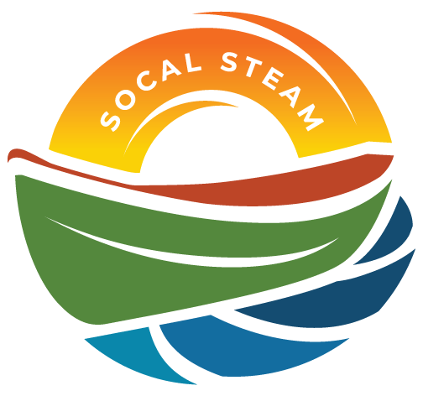
SoCal STEAM Challenge
Meeting with SoCal STEAM Committee
Date | Time 3/25/2026 4:00 PM
Location Sterling Natural Resource Center

Agenda Items
- Welcome and Introductions

- Approval of Committee Meeting Minutes from February 11, 2026

- Discussion Items
  - School Insurance
  - PSA Outline (no pt given. Do we want to still request them)

- Updates
  - Schools participating
  - Sunday Catering (Tacos secured)
  - Event wristbands
  - Timeline of Events

- Rules
  - Insurance
  - Boat number signs

- Review Task List

- Additional Items/Discussion
- Look for team flags

- Next Meeting – April 23rd at YRP

- Adjourn –

