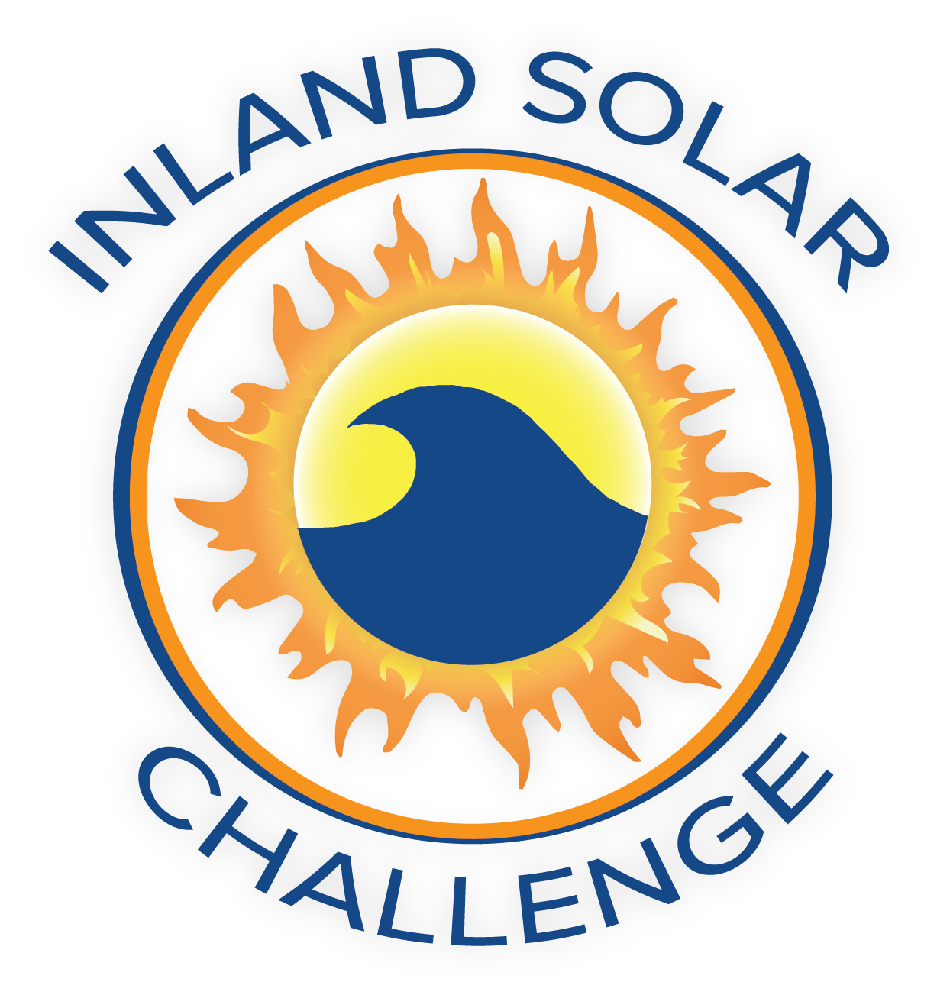
SoCal STEAM Challenge
TBD

Meeting with SoCal STEAM Committee
Date | Time 12/10/2024 9:00 AM Location Microsoft Teams
Join the meeting now
Meeting ID: 271 257 692 68
Passcode: Nm9Nw25d

Agenda Items
- Welcome and Introductions
  - San Bernardino Municipal Water Department
  - Yucaipa Valley Water District
  - East Valley Water District
  - West Valley Water District
  - City of Redlands
  - City of Colton
  - San Bernardino Valley Municipal Water District
  - City of Ontario

- Approval of Committee Meeting and Teacher Meeting Minutes from August 28, 2024

- Discussion/Action Items
  - Rule Revisions and Approval
  - Approve changes to Board of Directors
  - Approval of Consultant for Logo Design
  - New School Participation Request and Approval

- Task List

- Yucaipa Regional Park
  - Event Date Secured: May 2-4, 2025, draft contract received for review
- 501c3
  - Status Update: processing and file of name change
  - Sponsorships
  - File Taxes

- Public Service Announcement (PSA)
  - Topic Finalized

- Budget
  - Current
  - Invoicing
  - Sponsorships

- Art Element
  - Discussion: New Craftsmanship Rubric

- Additional Items
  - Sponsorship Thank You’s and Requests for 2025- SGPWA and SBVMWD
  - Boat Kits- Status of Kit pick-up and inventory

- Next Meeting
  - January 23, 2024, 9:00 AM

- Adjourn

