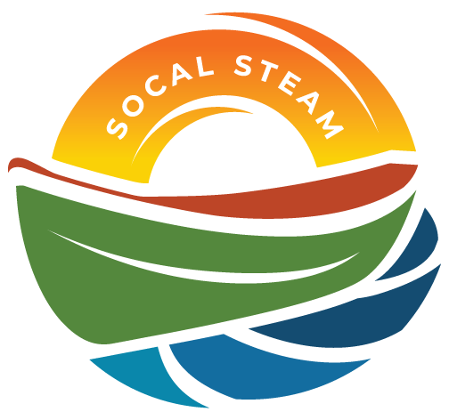
SoCal STEAM Challenge
Meeting with SoCal STEAM Committee
Date | Time 3/25/2026 4:00 PM
Location Sterling Natural Resource Center

Agenda Items
- Welcome and Introductions – Meeting Open 4:06 p.m.
East Valley Water District: Janett Robledo, Cecilia Contreras
Yucaipa Valley Water District: Jennifer Ares, Micah Knox
San Bernardino Municipal Water Dept.: Darian Brown, Devin Arciniega
City of Colton: Cecilia Griego

- Approval of Committee Meeting Minutes from February 11, 2026
Motion: Jennifer Ares Second: Darian Brown Motion Passed.

- Discussion Items
  - School Insurance – Treasurer Contreras updated insurance requirements and presented the changes to committee for vote.
Motion: Micah Knox, Second: Janett Roledo. Motion Passes.
Chair Robledo will send out an updated version of the rules with the changes to all the teachers/advisors.

  - PSA Outline (no pt given. Do we want to still request them) – Discussion regarding if there should be points given for the outline or if this portion of the event should be taken out. Committee discussed that this item helps to ensure that teams are up to date on items and will keep this item as a needed submission.

- Updates
  - Schools participating – Banning has backed out of the event due to medical issues with their advisor. The current total number of schools participating is now eight.
  - Sunday Catering (Tacos secured) – Treasurer Contreras has secured Sunday’s catering.
  - Event wristbands – Branded vinyl bracelets will be used to ensure that only event participants and invited guests will be given food during the Sunday catering. Historically, the committee has not been able to ensure that park guests that are
  - Timeline of Events – As motion passed for school insurance changes, Chair Robledo will update timeline for submission of required event forms. Deadline will be changed from April 17 to April 24, 2026 and will send the new information to the teachers/advisors.

- Rules
  - Insurance – rules changes made and will be sent out.
  - Boat number signs – Based on the last committee meeting minutes, Chair Robledo has made the changes to the rules regarding the boat number sign holders to reflect that the committee will not be providing holders, but they are still needed.

- Review Task List
Task list reviewed and updated. Chair Robledo has asked all committee members who will be reaching out to sponsors to respond back by April 12 and for those who will be reaching out to organizations to grade reports to respond back by April 23. Committee member Arciniega will be bringing in the PA system.

- Additional Items/Discussion
- Look for team flags – Team Yucaipa and committee member Arciniega will look in their respective event storage to find the missing flags.

- Next Meeting – April 23rd at YRP

- Adjourn – 5:13 p.m.

