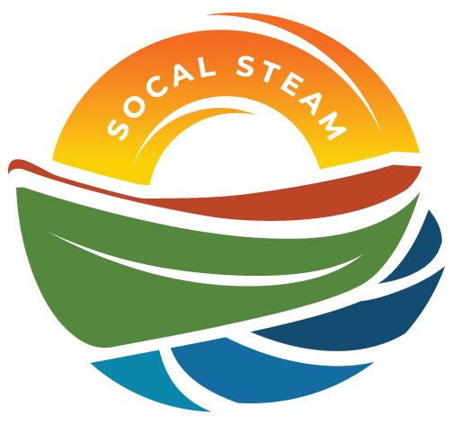
SoCal STEAM Challenge
Meeting with SoCal STEAM Committee
Date | Time 4/23/2026 11:00 AM
Location Yucaipa Regional Park

Agenda Items
- Welcome and Introductions

- Approval of Committee Meeting Minutes of March 26, 2026

- Discussion Items
  - Timeline of event weekend schedule
    - Check In/Tech Inspections/Qualifying
    - Sprint/Slalom/Craftmanship judging/PSA
    - Endurance/Awards
  - Event set up
  - Items needed from agencies
    - EZ Ups
    - Tables
    - Chairs
    - Golf carts
    - Grill
    - Ice Chest
  - Purchase of firewood (for Fri and Sat. Do we need 2 or 4 bundles of firewood?)
- Volunteers
    - Tech Inspectors
      - Friday
        - Jonathan, Steven, Jace, Wade, Mia
      - Saturday
        - Jonathan, Steven, Jace
      - Sunday
        - Jonathan, Steven, Jace
    - Food
      - Friday
        - Lunch: 3
        - Dinner: 6
      - Saturday
        - Breakfast: 7
        - Lunch: 6
        - Dinner: 5
      - Sunday
        - Breakfast: 3
        - Lunch: 2
    - Races
      - Sprint - 4
      - Slalom – 2
      - Endurance - 8

- Review Task List
  - Committee task assignments
    - Social Media/Photos – Darian/Devin
    - Kitchen - Cecilia
    - Grading – Devin/Adrian
    - VIP Host (Help being the contact person, craftmanship grading, PSA judging)- Cecilia G.
    - PSA Set Up –
    - Tech Inspectors – Jonathan
    - Bonfire Duty – Jennifer
    - Lake Set up/Clean up – Matt flo/Yucaipa
    - Banner Set Up – Entrance, Lake, Kitchen- Yucaipa
    - Caterer touch point - Cecilia/Mary Jo (We will cut off bracelets as they get their meals. Someone to help her pass out wristbands for spectators)
    - Jet Skis –
- Budget Update
  - SGPWA Sponsorship

- Committee Attire
  - Friday – Free day
  - Saturday – T-shirt
  - Sunday – Polo
- Additional Items/Discussion
- Check propane levels
- Battery Sign off stickers – Do we have them
- Vice Chair Nomination

- Next Meeting – June 11th

- Adjourn –

